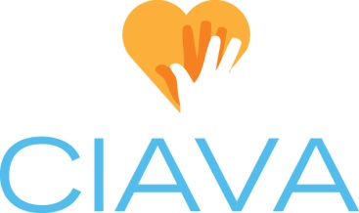
Board Position Description: Communication Chair
Updated 1/25/2021

CIAVA Mission: To shape the future of volunteerism by promoting and strengthening the profession of volunteer services management.

Position Status: This is an elected board position with voting privileges.

Time Commitment: Board & Membership preparation & attendance (6 hrs./month), July Board Retreat (2-3 hours preparation; 8-12 hours attendance and participation, hrs./yr.), Conference (8-12 hrs./yr. preparation, attendance, and facilitation), Annual June Luncheon planning (2 hrs./yr.). Monthly meetings: update website copy and resources; send meeting reminders on Facebook; create Zoom meetings, happy hours and coffee chats; help facilitate virtual happy hours and coffee chats (5 hrs./month).

Overview: The Communication Chair is responsible for some aspects of monthly meeting management. This includes (but is not limited to) coordinating meeting information on website and social media, sending meeting reminders via social media; creating Zoom meetings, coffee chats and happy hours; as well as help facilitate virtual happy hours and coffee chats (5 hrs./month). The Communication Chair is also responsible for the promotion of job opportunities, volunteer management resources, and local calls to action via CIAVA social media accounts in an effort to encourage member engagement, recruitment, and retention.

Tasks:
- Attend monthly Board meetings, annual Board Retreat, additional meetings like happy hours and coffee chats; and monthly membership meetings. Promote and share resources via social media to encourage member engagement, recruitment, and retention.

- Monthly Meetings:
  - Confirm topic and copy to be used to promote meeting (Consult with VP)
  - Update website copy and resources to reflect that month’s meeting
  - Send meeting announcement on social media (14-16 days prior to meeting).
  - Send meeting reminder on social media (7 days prior to meeting).
  - Day of in-person meeting: Unlock building, meet caterer, check room setup, and setup A/V equipment, name tag station, and CIAVA banners. Hand out name tags and mingle with members.
  - Day of virtual meeting: start Zoom meeting and let members in from waiting room
  - Upload and promote any resources collected after meeting has concluded

- May/June: Work with VP, Education Chair, and Hospitality Chair to coordinate the Annual June Luncheon – logistics, invitation, speaker, center pieces, gifts, etc.

Documentation:
- Maintain monthly copy uploaded to CIAVA website and social media through DropBox
- Post and event history stored in Facebook

