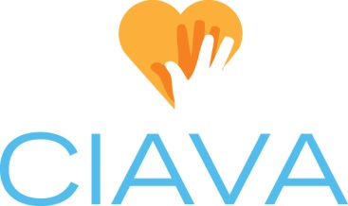
Board Position Description: Vice President
Created 03.19.2021

CIAVA Mission: To shape the future of volunteerism by promoting and strengthening the profession of volunteer services management

Position Status: This is an elected board position with voting privileges

Time Commitment: Board & Membership preparation & attendance (8 hrs./month), July Board Retreat (12 hrs./yr.), Summit (12-20 hrs. planning plus 8-10 hrs. attendance)

Overview: The Vice President is responsible for overseeing the coordination and proper execution of CIAVA Membership Meetings. In the absence of the President, the Vice President shall conduct board and membership meetings.

Tasks:
- Oversee content development for CIAVA Membership Meetings
  - Work with the Board to develop a comprehensive meeting plan for the year during the Board retreat in July
  - Assist with and ensure the plan for each meeting is sound and followed through on in a manner that meets the standards of the organization
  - Coordinate which board members will be in charge of planning each meeting throughout the year
  - Ensure there is a board member that will serve as the MC for each meeting
  - If no other board members wish to MC a meeting, then the Vice President shall serve in this role
  - Verify the following are secured in advance of each meeting
    - Monthly email communicating the topic for the next CIAVA Membership Meeting
    - Ensure a proper bio is secured for any and all guest speakers for formal introduction to membership
    - Confirm AV or virtual presentation needs and coordinate execution of those needs when applicable
    - Coordinate follow up with any and all guest speakers including thank you notes and member feedback received from the survey administered following each meeting
    - Coordinate any gifts the organization may impart on guest speakers
- Conduct board and membership meetings in the absence of the President
- Attend monthly board meetings as a voting member of the board
- Work with President and Treasurer to develop annual budget
- At term-end, arrange for the transfer of records to the incoming Vice President
- Coordinate and execute the Midwest Volunteerism Summit annually

Documentation:
- Work with the board to ensure proper documentation and archiving of meetings and educational components
- Ensure all aspects of the Midwest Volunteerism Summit are captured and stored for future use

