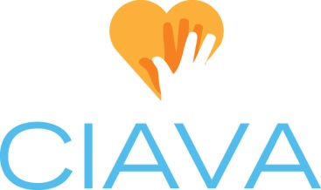
Board Position Description: President
Created 1.27.2021

CIAVA Mission: To shape the future of volunteerism by promoting and strengthening the profession of volunteer services management.

Position Status: This is an elected board position with voting privileges.

Time Commitment: Board & Membership preparation & attendance (6 hrs./month), July Board Retreat (8 hrs./yr.), Conference (10-20 hrs./yr. plus 8-9 hrs. attendance & facilitation), June Luncheon planning (5 hrs./yr.)

Overview: Provide leadership to define and reach goals and objectives of the association. Convene and direct discussion of issues via regular board meetings. Provide direction to encourage membership expansion. Enhance the value of the association for the membership through defining, upgrading, and promoting education and training opportunities for the membership.

Tasks:
- Responsible for ensuring the association operates within its adopted by-laws. Acts on proposed revisions to by-laws. Recommends policies that determine the purpose, governing principles, functions, and activities of the association.
- Facilitate monthly meetings of the general membership. Presiding at all meetings of the association in an unprejudiced manner.
- Regularly monitors the activities of the association including committee work, proposals, and operations.
- Understands and interprets the work of the association to other interested parties and organizations.
- Approves and monitors the association’s finances.
- Participates in planning, monitoring, and evaluation of programs of the association.
- Chair board meetings.
- Supervise and maintain communication with executive committee and committee chairs.
- Be an advocate for the profession and CIAVA.
- Represent CIAVA locally, nationally, and internationally.
- Remain current on national trends and issues affecting volunteer management.
- Attend monthly Board meetings as a voting member of the Board.
- Website contribution: Provide New/Updated “Letter from the President” in July/August of each year.
- Provide Historian with Board Membership List and yearly "Letter from the President”.

Requirements:
- Must be a current dues-paying member of the association.
- Demonstrates interest in the goals and objectives of the association with a commitment to participate in all board meetings, serve on committees, and engage in activities.
- The responsibilities and duties listed above are intended only as illustrations of the various types of work that may be performed.

Qualifications: Candidate who holds a current Certification in Volunteer Administration (CVA) is preferred.

