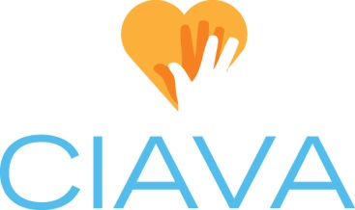
Board Position Description: Membership Chair
Updated 4/16/2021

CIAVA Mission: To shape the future of volunteerism by promoting and strengthening the profession of volunteer services management.

Position Status: This is an elected board position with voting privileges.

Time Commitment: Board & Membership meeting preparation & attendance (6 hrs./month), July Board Retreat (2-3 hours preparation; 8-12 hours attendance and participation, hrs./yr.), Conference (8-12 hrs./yr. preparation, attendance, and facilitation), Annual June Luncheon planning (2 hrs./yr.). Membership renewal activities during annual enrollment period (12-15 hrs/yr); Monthly meetings: answer membership questions, actively engage new, returning, and prospective CIAVA members (1 hrs./month)

Overview: The Membership Chair is responsible for actively engaging and recruiting potential CIAVA members and providing information about the organization.

Tasks:
- Attend monthly Board meetings, annual Board Retreat, additional meetings like happy hours and coffee chats; and monthly membership meetings.
- Compose and send initial membership letter/email to former members and mailing list
- Notify and follow-up with members regarding upcoming expiration of membership
- Receive new memberships, input data, and forward checks to Treasurer.
- Send and distribute membership information upon request and answer membership questions directed to info@ciava.org email
- Maintain database of active members
- Attend monthly meetings as a voting member of the board

- Monthly Meetings:
  - Provide membership summary including number of new, past, and archived members at board meetings
  - Make announcements and keep members up-to-date of upcoming renewal periods and dates to know
  - Answer questions regarding memberships
  - Day of in-person meeting: Assist with check-in and handing out name tags and mingle with members.

- May/June:
  - Work with VP, Education Chair, and Hospitality Chair to coordinate the Annual June Luncheon – logistics, invitation, speaker, center pieces, gifts, etc.
  - Prepare for annual enrollment period (June-August) by renewing returning members and enrolling new members

Documentation:
- Maintain Membership Invite Letter in Google Docs
- Provide new/updated membership brochure to be posted on website

