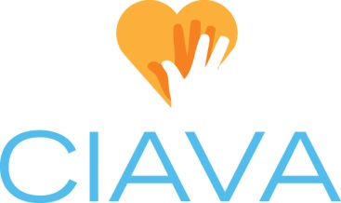
Board Position Description: Education Chair
Created 7/8/09, Updated 9/10/14

CIAVA Mission: To shape the future of volunteerism by promoting and strengthening the profession of volunteer services management.

Position Status: This is an elected board position with voting privileges.

Time Commitment: Board & Membership preparation & attendance (6 hrs/mth), July Board Retreat (8 hrs/yr), Conference (10-20 hrs/yr plus 8-9 hrs attendance & facilitation), June Luncheon planning (5 hrs/yr)

Overview: Oversee the Educational components of the organization such as: brown bag sessions, basic & advanced series, mentoring, conference, and CVA study groups. Work directly with the Vice President as needed to coordinate topics for monthly meetings in relationship to other educational offerings.

Tasks:
- Develop and execute additional learning opportunities (beyond the monthly membership meetings) for the members of CIAVA. This could be in the form of brown bag lunch topical quarterly meetings, a Basic Training series for new Volunteer Managers, or an Annual Conference for Central Indiana. Final selection of activities is made by the board.
- Work in cooperation with other professional organizations such as Serve Indiana, the Association for Fundraising Professionals, the Association for Healthcare Volunteer Resource Professionals and / or ALIVE to offer and provide a wide variety of educational opportunities to the CIAVA membership.
- Promote the Certified Volunteer Administrator (CVA) credential. Provide support to candidates participating in the accreditation cycle as needed - organize study groups, provide sample written portfolios, coordinate testing site with proctor. Track the usage of, and store 2 CVA study books owned by CIAVA.
- Social media contribution: Provide Communications/Social Media chair with information for relevant training opportunities, conference registration information/fliers, volunteer nomination information (like Diversity Award or Jefferson Award), and service fairs.
- Attend monthly Board meetings & Retreat and membership meetings.
- Work with VP and Hospitality to coordinate the June Luncheon – logistics, invitation, speaker, center pieces, gifts, etc.

Documentation:
- Keep a record of all CIAVA members who have obtained the CVA.
- Provide a final report, including financials, for any conferences or outside training events. (Topic, Speaker, Location, Cost for member/non-member, # attended, expenses / revenue, etc.) Maintain a running record of conference speakers and dates.
- Maintain June luncheon history – speaker, invitation, gift information (item, cost & vendor), theme, etc.

Note: The Education chair may utilize subcommittees or recruit members to assist with education activities, such as the June luncheon or Conference, as needed. These participants are not required to attend board meetings and do not have board voting privileges.

